Heart Disease Analysis

Define Problem / Problem Understanding
Heart disease continues to be one of the leading causes of mortality worldwide. Rapid lifestyle changes, unhealthy food habits, stress, lack of physical activity, smoking, and increasing obesity levels have significantly contributed to the growth of cardiovascular diseases. Healthcare institutions collect large volumes of patient data including age, cholesterol levels, blood pressure, body mass index, smoking status, and physical activity levels. However, this data often remains underutilized because it is not analyzed effectively.
The core problem in this project is the lack of a structured and visual approach to understanding heart disease risk factors from large datasets. Traditional analysis methods such as spreadsheets and manual reports are not sufficient to identify hidden patterns and correlations in medical data. Therefore, there is a need for an interactive and visual analytics solution that can transform raw healthcare data into meaningful insights.
This project focuses on solving this problem using Tableau, a powerful data visualization tool. By applying business intelligence techniques, the system aims to uncover trends, identify high-risk groups, and support preventive healthcare decisions. The goal is not only to analyze data but also to present it in a way that is simple, interactive, and actionable.

Specify the Business Problem
From a business perspective, healthcare institutions and government health departments need reliable analytical tools to support data-driven decisions. Hospitals must identify high-risk patients early to reduce treatment costs and improve patient outcomes. Government bodies must understand disease prevalence trends to design preventive policies and awareness campaigns.
The business problem addressed in this project is how to provide healthcare stakeholders with an interactive dashboard that clearly highlights heart disease trends and risk factors. The solution must allow filtering by age, gender, region, and lifestyle indicators. It should enable quick comparisons between different population groups.
By solving this business problem, hospitals can improve patient screening efficiency, policymakers can create targeted health programs, and individuals can become more aware of their health risks. This project aims to bridge the gap between raw medical data and meaningful decision-making through effective visualization.

Business Requirements

Include creating a scalable, interactive, and user-friendly analytics solution. The dashboard must present key such as total patients, high-risk cases, average cholesterol levels, and average ive filtering options
• Clear graphical representations
• Identification of high-risk categories
• Easy interpretation for non-technical usersllow stakeholders to drill down into specific data segments. Performance optimization is also a h as smoking, obesity, physical inactivity, and high cholesterol. Medical research emphasizes early detection and preventive measures as key strategies to reduce mortality.
Recent advancements in healthcare analytics highlight the importance of business intelligence tools in improving decision-making. Visualization tools like Tableau arerough early intervention. Insurance providers can design better risk assessment strategies. Government agencies can allocate healthcare resources efficiently based on data-driven insights.
The project promotes preventive healthcare rather than reactive treatment. This contributes to both economic savings and improved public health outcomes.

Literature Survey
Several studies indicate that heart disease is strongly linked to modifiable lifestyle factors such as smoking, obesity, physical inactivity, and high cholesterol. Medical research emphasizes early detection and preventive measures as key strategies to reduce mortality.
Recent advancements in healthcare analytics highlight the importance of business intelligence tools in improving decision-making. Visualization tools like Tableau are widely used in healthcare organizations to monitor disease patterns and patient data trends.
This project builds upon existing research by integrating heart disease data with modern visualization techniques. It supports analytical exploration and encourages data storytelling to make findings accessible to diverse stakeholders.
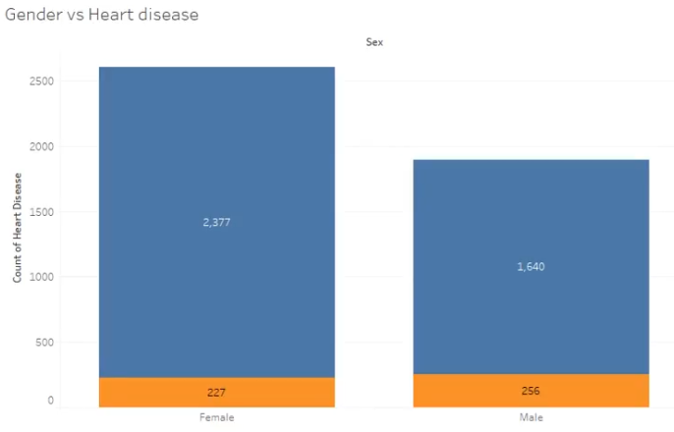

Social or Business Impact
The social impact of this project is significant. By identifying high-risk populations, preventive healthcare initiatives can be implemented more effectively. Increased awareness about obesity, smoking, and sedentary lifestyles can reduce future heart disease cases.
From a business perspective, hospitals can reduce treatment costs through early intervention. Insurance providers can design better risk assessment strategies. Government agencies can allocate healthcare resources efficiently based on data-driven insights.
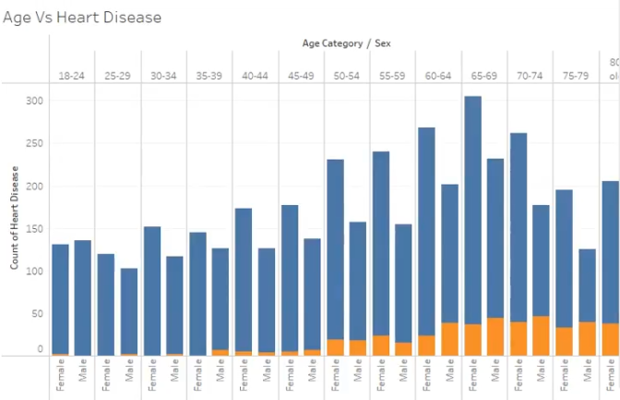

The project promotes preventive healthcare rather than reactive treatment. This contributes to both economic savings and improved public health outcomes

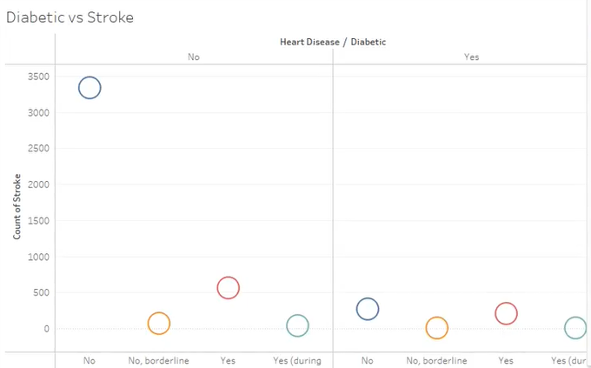

Data Collection & Extraction from Database
The dataset used in this project includes structured information such as patient demographics, cholesterol levels, blood pressure readings, BMI values, smoking status, and physical activity indicators.
Data was collected from reliable healthcare datasets and stored in a relational database system. SQL queries were used to extract relevant fields and perform aggregation operations.
The extraction process ensures that only necessary and clean data is imported into Tableau for visualization. Proper validation checks were applied to maintain data integrity.
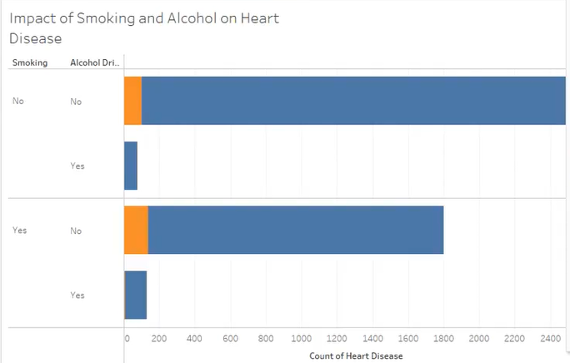

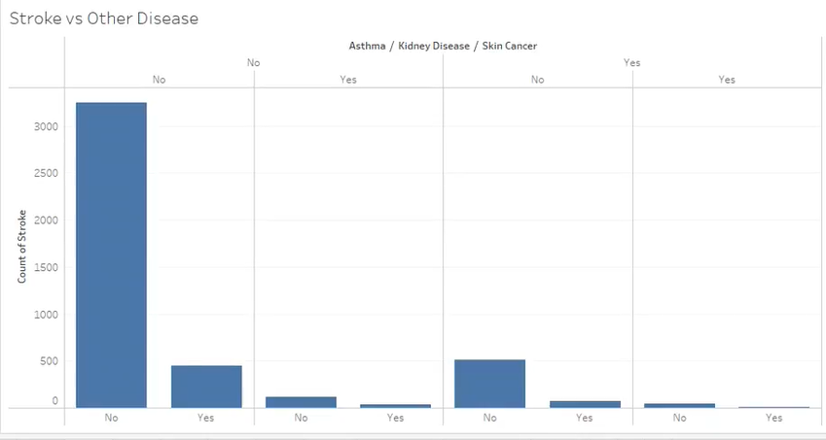

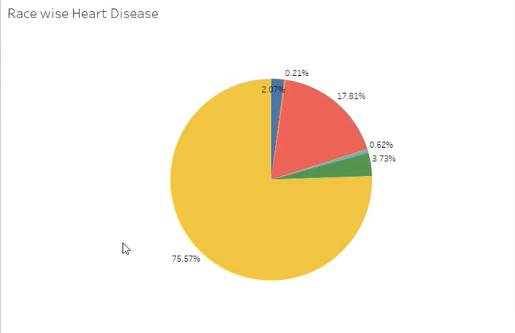

Storing Data in Database & SQL Operations
The collected dataset was stored in a structured relational database using appropriate table design. Each patient record includes attributes such as Patient ID, Age, Gender, Cholesterol, Blood Pressure, BMI, Smoking Status, and Region.
SQL operations performed include:
• SELECT queries for data retrieval
• WHERE clauses for filtering
• GROUP BY for aggregation
• JOIN operations for combining tables
• COUNT and AVG functions for KPI calculation
These SQL operations prepared the dataset for smooth integration with Tableau.

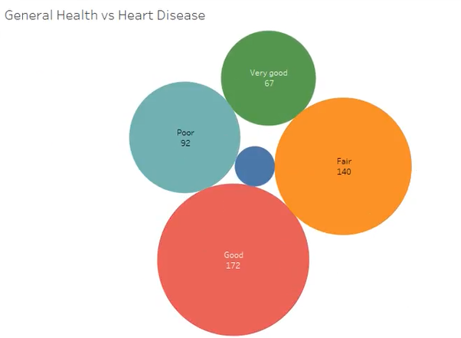

Connecting Database with Tableau
Tableau was connected directly to the database using a secure connection. The connection allowed either live queries or data extracts.
Once connected, the dataset was imported into Tableau’s data source page. Relationships between tables were verified, and data types were checked. This ensured accurate visualization results.
The integration between database and Tableau allowed seamless analysis and interactive filtering.

Data Preparation for Visualization
Data preparation involved cleaning and transforming raw data into structured formats suitable for analysis.
Steps included:
• Handling missing values
• Removing duplicate entries
• Creating calculated fields
• Grouping ages into categories
• Defining BMI classifications
Calculated fields such as Risk Category were created using logical expressions. These transformations improved visualization clarity.

Data Visualizations
The project includes 8–10 unique visualizations to analyze heart disease trends.
Visualizations include:
• Bar charts for age group comparison
• Pie charts for gender distribution
• Scatter plots for blood pressure analysis
• Heat maps for BMI and cholesterol
• Geographic maps for regional trends
Each visualization provides a different analytical perspective.

Number of Unique Visualizations
A total of 10 unique visualizations were developed in this project. Each visualization serves a specific purpose and supports different analytical objectives.
These visualizations collectively provide a comprehensive view of heart disease data and allow stakeholders to explore multiple dimensions.

Dashboard Design & Responsiveness
The dashboard integrates all visualizations into one interface. KPI cards are placed at the top, followed by charts and maps.
Filters allow users to dynamically change views based on age, gender, and region. The dashboard design ensures clarity and user engagement.
Responsiveness ensures proper display across devices.

Story Creation
A data story was created with multiple scenes explaining key findings step by step.
The story highlights:
• Identification of high-risk groups
• Correlation between lifestyle factors
• Regional comparisons
• Preventive recommendations
This narrative approach improves communication effectiveness.

Number of Story Scenes
The story includes 5–7 scenes. Each scene focuses on a specific analytical insight.
The scenes are structured logically to guide users from problem identification to preventive strategies.

Performance Testing
Performance testing evaluated dashboard loading time and filter responsiveness.
Optimization techniques include:
• Using data extracts
• Reducing unused fields
• Minimizing complex calculations
Testing ensures efficient performance even with large datasets.

Data Rendering & Filter Utilization
The dashboard renders thousands of records efficiently. Filters are applied to age group, gender, region, and risk category.
Efficient filter utilization enhances interactivity without affecting speed.
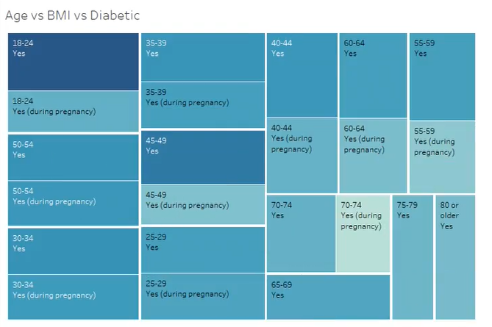

Calculation Fields & Graph Count
The project includes approximately 8–12 calculated fields. Examples include:
• Risk Category
• BMI Classification
• Age Group
• High Cholesterol Flag
A total of 10 visualizations and 1 integrated dashboard were developed.
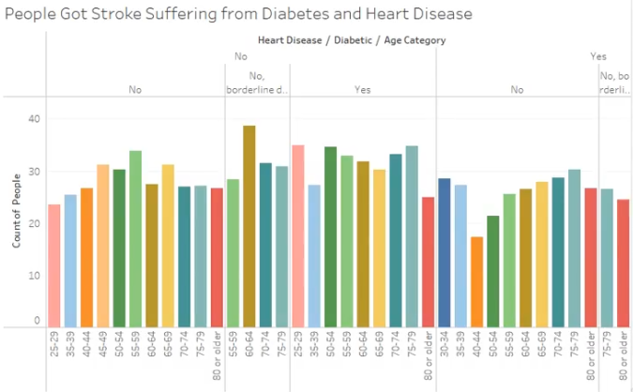

Web Integration Using Flask
The Tableau dashboard and story were embedded into a web application using Flask.
The process involved:
•Publishing dashboard
•Generating embed code
•Integrating into HTML template
• Running Flask server
This allows users to access interactive dashboards via browser.

Project Demonstration
The project demonstration video presents the complete workflow of the Heart Disease Analysis system developed using Tableau. The video begins with a brief explanation of the problem, highlighting the importance of analyzing heart disease data to identify major risk factors such as obesity, smoking, high cholesterol, and sedentary lifestyle.
Next, the data collection process is explained, including the dataset structure and how it was stored in a relational database. Basic SQL operations such as SELECT, WHERE, GROUP BY, COUNT, and AVG were performed to retrieve and summarize the required data.
The demonstration then shows how the database was connected to Tableau and how various visualizations were created, including bar charts, scatter plots, heat maps, and regional maps. These visualizations help identify high-risk groups and key health trends.
The dashboard design is presented with interactive filters and KPI indicators for better decision-making. Finally, the video explains how the Tableau dashboard and story were embedded into a web application using Flask.

Project Documentation
The project documentation provides a clear step-by-step explanation of the entire development process of the Heart Disease Analysis system. It covers problem definition, data collection, database setup, SQL operations, Tableau integration, visualization creation, dashboard design, and web deployment.
The documentation includes screenshots, diagrams, and brief explanations of each stage to help understand how the system was implemented. Each visualization and dashboard component is described along with the insights derived from it.
This documentation ensures reproducibility, making it easier for others to follow the same steps, modify the system, or extend the project in the future. It also serves as a reliable reference for academic evaluation and future enhancement

Conclusion
The Heart Disease Analysis project demonstrates how data visualization and business intelligence tools can be effectively used in the healthcare domain. By using Tableau, raw medical data was transformed into meaningful visual insights that highlight major risk factors such as obesity, smoking, high cholesterol, high blood pressure, and sedentary lifestyle.
The project successfully integrated database management, SQL operations, data preparation, and interactive dashboard development into a complete analytical solution. The visualizations and dashboards help identify high-risk groups and *support data-driven decision-making for healthcare professionals, policymakers, and individuals.
Through web integration, the solution was made accessible via a user interface, proving that analytical insights can be deployed beyond desktop environments. Overall, this project emphasizes the importance of preventive healthcare and shows how visualization tools can play a key role in reducing cardiovascular risk through better awareness and informed decisions

